1) I want a discount code on all packages. I can insert only one package at a time. I want that code is active for all packages. I can insert the heading "valid for all"?
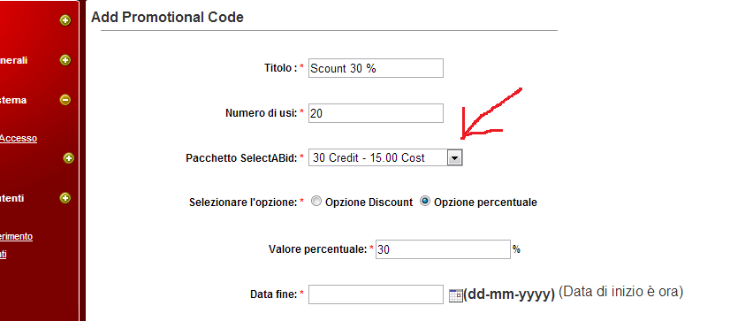
2) I want to be able to place banner advertising on these points.
